**Unit Conversion Program**

#include <stdio.h>

int main()

{

char category;

int tempChoice;

int currencyChoice;

int massChoice;

int userinputF; // User inputted Fahreinheit;

int userinputK;// User inputted Kelvin;

int userinputEurotoINR; // User inputted for Euro to INR;

int userinputUSDtoINR; // User inputted for USD to INR;

int userinputRMBtoINR; // User inputted for RMB to INR;

int userinputPoundtoINR; // User inputted for Pound to INR;

int userinputAUDtoINR; // User inputted for Euro to INR;

int userinputOunce; // User inputted for Ounce;

int userinputPounds; // User inputted for Pounds;

float fahrenheitToCelsius; // variable that stores the converted F->C;

float kelvinToCelsius; // variable that stores the converted K->C;

float EUROtoINR ; // varaible that stores the converted EURO->INR;

float USDtoINR; // stores the converted USD->INR;

float RMBtoINR; // stores the converted RMB->INR;

float PoundtoINR ; // varaible that stores the converted POUND->INR;

float AUDtoINR ; // varaible that stores the converted AUD->INR;

float ounceToGrams; // stores the converted Ounce->Grams;

float poundsToGrams; // stores the vonerted Pounds->Grams;

printf("Welcome to Unit Converter! \n");

printf("Here is a list of conversation to choose from: \n");

printf("Temperature(T),Currency(C),Mass(M) \n");

printf("Please enter the letter you want to convert.\n");

scanf("%c",&category);

if(category == 'T')

{

printf("Welcome to Temperature Converter! \n");

printf("Here is a list of conversations to choose from: \n");

printf("Enter 1 for Fahrenheit to Celsius. \n");

printf("Enter 2 for Kelvin to Celsius. \n");

scanf("%d",&tempChoice);

if(tempChoice == 1)

{

printf("Please enter the Fahrenheit degree: \n");

scanf("%d",&userinputF);

fahrenheitToCelsius = ((userinputF-32) * (5.0/9.0));

printf("Celsius: %f",fahrenheitToCelsius);

}

else if(tempChoice == 2)

{

printf("Please enter the Kelvin degree: \n");

scanf("%d",&userinputK);

kelvinToCelsius = userinputK-273.15;

printf("Celsius: %f",kelvinToCelsius);

}

else

printf("Please enter the correct choice. \n");

}

else if(category == 'C')

{

printf("Welcome to Currency Converter! \n");

printf("Here is a list of conversations to choose from: \n");

printf("Enter 1 for Euro to INR. \n");

printf("Enter 2 for USD to INR. \n");

printf("Enter 3 for RMB to INR \n");

printf("Enter 4 for Pound to INR \n");

printf("Enter 5 for AUD to INR \n");

scanf("%d",&currencyChoice);

if(currencyChoice == 1)

{

printf("Please enter the Euro amount: \n");

scanf("%d",&userinputEurotoINR);

EUROtoINR = userinputEurotoINR * 82.79;

printf("INR: %.2f",EUROtoINR); // %.2f = rounds the float to only 2 decimal places;

}

else if(currencyChoice == 2)

{

printf("Please enter the USD amount: \n");

scanf("%d",&userinputUSDtoINR);

USDtoINR = userinputUSDtoINR * 77.84;

printf("INR: %.2f",USDtoINR);

}

else if(currencyChoice == 3)

{

printf("Please enter the RMB amount: \n");

scanf("%d",&userinputRMBtoINR);

RMBtoINR = userinputRMBtoINR * 11.64;

printf("INR: %.2f",RMBtoINR);

}

else if(currencyChoice == 4)

{

printf("Please enter the pound amount: \n");

scanf("%d",&userinputPoundtoINR);

PoundtoINR = userinputPoundtoINR * 97.17;

printf("INR: %.2f",PoundtoINR);

}

else if(currencyChoice == 5)

{

printf("Please enter the AUD amount: \n");

scanf("%d",&userinputAUDtoINR);

AUDtoINR = userinputAUDtoINR * 55.38;

printf("INR: %.2f",AUDtoINR);

}

else

printf("Please enter correct choice. \n");

}

else if(category == 'M')

{

printf("Welcome to Mass Converter! \n");

printf("Here is a list of conversations to choose from: \n");

printf("Enter 1 for ounces to grams. \n");

printf("Enter 2 for pounds to grams. \n");

scanf("%d",&massChoice);

if(massChoice == 1)

{

printf("Please enter the ounce amount: \n");

scanf("%d",&userinputOunce);

ounceToGrams = userinputOunce * 28.3495;

printf("Grams: %.2f",ounceToGrams);

}

else if(massChoice == 2)

{

printf("Please enter the pounds amount: \n");

scanf("%d",&userinputPounds);

poundsToGrams = userinputPounds * 453.592 ;

printf("Grams: %.2f",poundsToGrams);

}

else

printf("Please enter the correct choice. \n");

}

return 0;

}

**OUTPUT 1:**

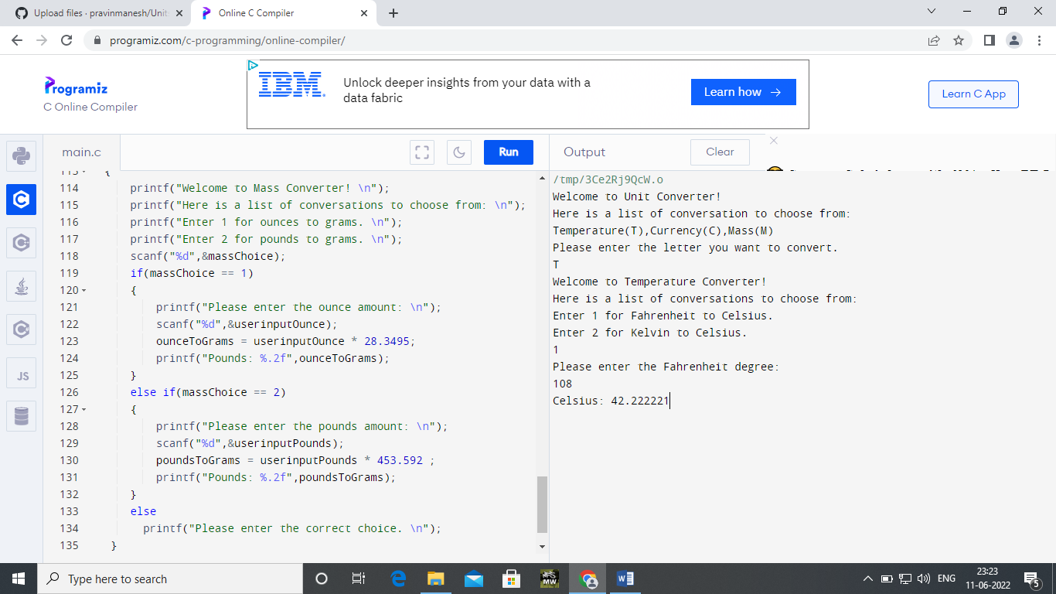

**OUTPUT 2:**

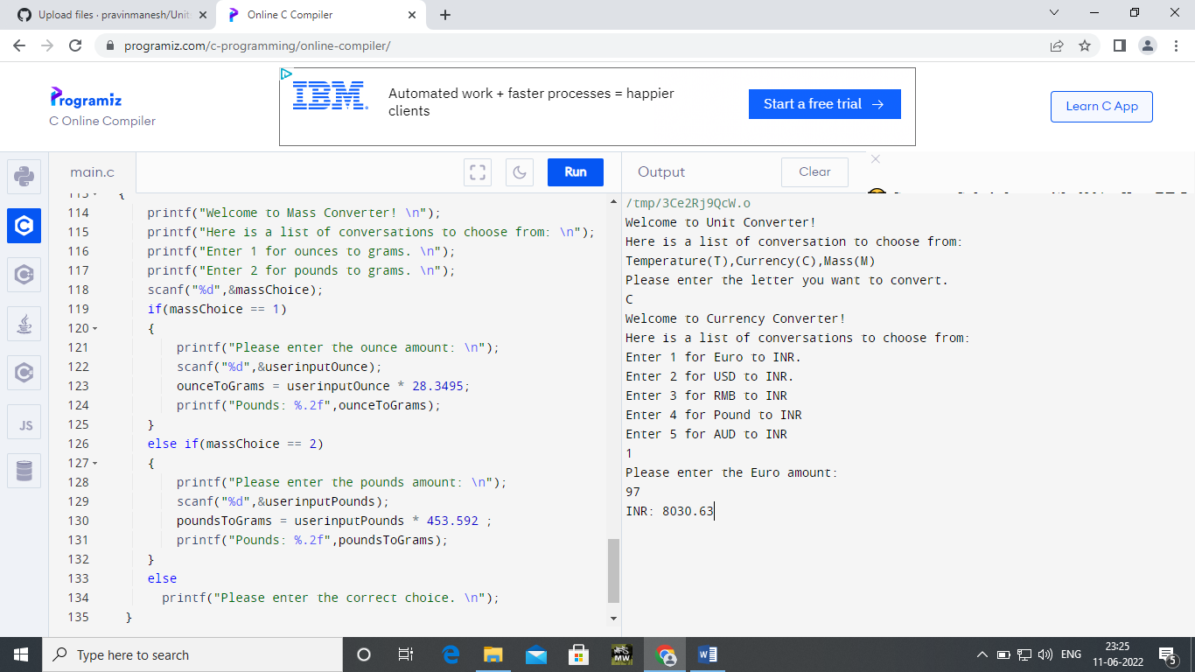

**OUTPUT 3:**

